

**Nomadycs**

**High Level Solution Design**

**Version 1.00**

**Amendment History**

|  |  |  |  |
| --- | --- | --- | --- |
| **Version** | **Date** | **Description** | **Authors** |
| 0.01 | 12-Dec-2014 | Initial Draft | Yuvaraja N |
| 1.00 | 12-Dec-2014 | Base lined | Yuvaraja N |
|  |  |  |  |

Contents

1. Introduction 3

2. Components & Technology 3

3. Deployment Architecture 5

4. Web Services Design 6

5. Project Solution Structure 7

# Introduction

Nomadycs is a web based application to manage various cataog entities related to industries like HVAC, etc. The application provides mechanism for different users to login and manage catalog entities at different permission levels.

This document details out technology used in Nomadycs and Project solution structure.

# Components & Technology



Different component and technology used in Nomadycs application is as below:

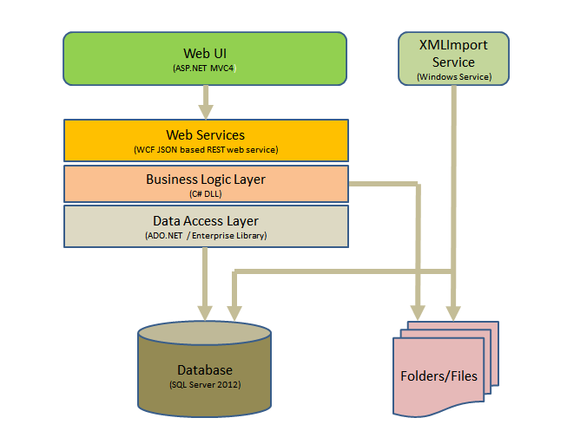

Following technologies have been identified for the development of components for the Nomadycs system.

|  |  |
| --- | --- |
| **Platform** | Microsoft Windows |
| **Framework** | Microsoft .NET 4.5 |
| **Development Environment** | Visual Studio 2012 |
| **Web applications** | ASP.NET MVC 4 |
| **Services development** | Windows Communications Foundation (WCF) |
| **Database** | SQL Server 2012 |
| **Data Access, Exception Handling and Logging** | Microsoft Enterprise Library |
| **Other tools** | jQuery, Bootstrap |
| **XML Editor** | Xonomy, etc.  (POC to be done on XML tools to finalise on this) |
| **Email Integration** | SMTP server integration for sending emails.  (Infomill to provide SMTP server related details) |

# Deployment Architecture

The deployment architecture of Nomadycs solution is given in below diagram.

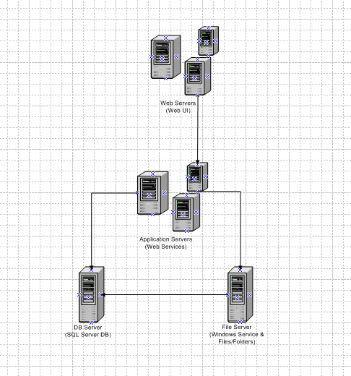

**Note:** File Server is mentioned for keeping up of all files related to Job processing. (It need not related to document/image files associated with DB server tables.

File Server is optional one. If DB server has enough hardware support, Windows Service (XMLImport Service) and list of files can be kept it in DB server itself.

# Web Services Design

Separate web service will be created for major entities in Nomadycs application. The list of services will be,

* ManufacturerGroup Service
* Manufacturer Service
* Model Service
* PartsList Service
* PartsListSection Service
* Part Service
* Folio Service
* Document Service
* Job Service
* Task Service
* Stockist Service
* FieldServiceCompany Service
* TradeCounter Service
* User Service
* XmlImport Service
* Login Service
* Product Service – It is for Product Type and Product Range entities

**Technology:**

* Web services will be developed as “WCF Service Application” project types in Visual Studio 2012.
* Web Services will be developed as JSON based REST services. (Web based binding will be used for it).
* Service facades will not be considered for the web services as it is internal web services for Nomadycs application.
* Authentications will not be provided at the service level. (Nomadycs will only consume the services)
  + **Note:** Session based validation can be done at each service method calling. But it will have a Database hit for each method calling that will introduce performance hit. To be discussed with Infomill to finalise on this.
* Using Web Request methods in C#, WCF service will be consumed in UI application.

# Project Solution Structure

Based on layers and components segregations, below solution files have been identified for Nomadycs application.

|  |  |  |
| --- | --- | --- |
| **S.No** | **Solution Name** | **Description** |
| 1 | Infomill.Nomadycs.WebUI.sln | This solution file contains all project files required for UI application. This solution file can be deployable into Web servers. |
| 2 | Infomill.Nomadycs.WebService.sln | This solution file contains all project files required for Web service layer. It includes projects related for Business Logic and Data access layers.  This solution file is deployable on Application servers. |
| 3 | Infomill.Nomadycs.XmlImportService.sln | This solution file contains Windows service related project to do XML File Import related operations. |

Infomill.Nomadycs.WebUI.sln (UI Solution)

List of project files in this solution is as below:

|  |  |  |
| --- | --- | --- |
| **S.No** | **Project file** | **Description** |
| 1 | Infomill.Nomadycs.UI.csproj | It is a ASP.NET MVC4 project.  Main UI project for Nomadycs Web application. |
| 2 | Infomill.Nomadycs.Utilities.csproj | It is a C# DLL  Common functionalities like Logging, Exception handling is mentioned here. |

**UI Project folder structure is as below:**

|  |
| --- |
| * Infomill.Nomadycs.WebUI –> It is a root folder. It contains below details.  1. Infomill.Nomadycs.WebUI -> It is a solution file 2. WebUI –> It is folder. It contains.    1. Infomill.Nomadycs.UI.csproj - ASP.NET MVC4 cs project file    2. Properties – it is default folder    3. References – default folder    4. Service References – default folder    5. App_Data – default folder    6. App_Start – default folder    7. Content – folder. It contains,       1. Scripts – folder. It contains all .js files       2. CSS – folder. It contains all .css files       3. Images – folder. It contains image files used in Nomadycs web application.    8. Controllers       1. It will have sub folders based on logically related items    9. Models    10. Views        1. Shared – folder. It contains common layout cshtml files.        2. Separate folder for each controller related views. |

Infomill.Nomadycs.WebService.sln (Web Service Solution)

List of project files in this solution is as below:

|  |  |  |
| --- | --- | --- |
| **S.No** | **Project file** | **Description** |
| 1 | Infomill.Nomadycs.ManufacturerGroupService.csproj | It is a WCF Service Application project.  All Manufacturer Group related functionalities like Create, Edit, etc will be handled here. |
| 2 | Infomill.Nomadycs.ManufacturerService.csproj | All Manufacturer Related functionalities are handled here. |
| 3 | Infomill.Nomadycs.ModelService.csproj |  |
| 4 | Infomill.Nomadycs.PartsListService.csproj |  |
| 5 | Infomill.Nomadycs.PartsListSectionService.csproj |  |
| 6 | Infomill.Nomadycs.PartService.csproj |  |
| 7 | Infomill.Nomadycs.FolioService.csproj |  |
| 8 | Infomill.Nomadycs.DocumentService.csproj | All Document related functionalities are handled here.  DocumentType related functionalities are handled here. |
| 9 | Infomill.Nomadycs.StockistService.csproj |  |
| 10 | Infomill.Nomadycs.FieldServiceCompanyService.csproj |  |
| 11 | Infomill.Nomadycs.TradeCounterService.csproj |  |
| 12 | Infomill.Nomadycs.JobService.csproj |  |
| 13 | Infomill.Nomadycs.TaskService.csproj |  |
| 14 | Infomill.Nomadycs.XmlImportService.csproj | Only Nomadycs UI related operation for XmlImport process will be available here. |
| 15 | Infomill.Nomadycs.UserService.csproj |  |
| 16 | Infomill.Nomadycs.LoginService.csproj |  |
| 17 | Infomill.Nomadycs.ProductService.csproj | Product Type, Product Sub Type, Product Range related functionalities are handled here. |
| 18 | Infomill.Nomadycs.BLL.csproj | It is a C# DLL library.  All Business logic layer related functionalities are handled here. |
| 19 | Infomill.Nomadycs.DAL.csproj | It is a C# DLL library.  All Data access logic related functionalities are handled here.  It uses Enterprise Library for database interaction. |

Infomill.Nomadycs.XmlImportService.sln (Window Service Solution)

List of project files in this solution is as below:

|  |  |  |
| --- | --- | --- |
| **S.No** | **Project file** | **Description** |
| 1 | Infomill.Nomadycs.XmlImporter.csproj | It is a Windows Service project. |